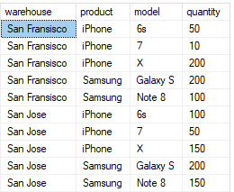**Task No. 1:** Create table inventory as follows and insert the following values:

.

**Solution:**

**Question #1:** Use the GROUP BY clause and the SUM() function to find the total inventory by warehouse

**Solution:**

SELECT Warehouse, SUM(Quantity) AS TotalInventory

FROM inventory

GROUP BY Warehouse;

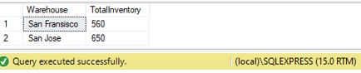

**Question #2:** Retrieve the total products in all warehouses by using rollup.

**Solution:**

SELECT Warehouse, Product, SUM(Quantity) AS TotalInventory

FROM inventory

GROUP BY ROLLUP (Warehouse, Product);

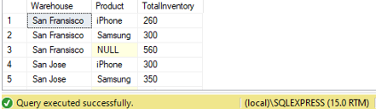

**Question #3:** Use COALESCE function to set Null value to 'All Warehouses'.

**Solution:**

SELECT COALESCE(Warehouse, 'All Warehouses') AS Warehouse, Product, SUM(Quantity) AS TotalInventory

FROM inventory

GROUP BY ROLLUP (Warehouse, Product);

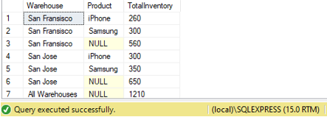

**Question #4:** Calculate the inventory by warehouse and product.

**Solution:**

SELECT Warehouse, Product, SUM(Quantity) AS TotalInventory

FROM inventory

GROUP BY Warehouse, Product;

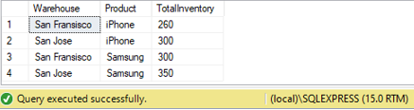

**Question #5:** Introduce rollup to query 4.

**Solution:**

SELECT Warehouse, Product, SUM(Quantity) AS TotalInventory

FROM inventory

GROUP BY ROLLUP (Warehouse, Product);

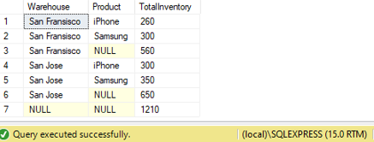

**Question #6:** Use rollup with only product column and show the output.

**Solution:**

SELECT COALESCE(Product, 'Total') AS Product, SUM(Quantity) AS TotalInventory

FROM inventory

GROUP BY ROLLUP (Product);

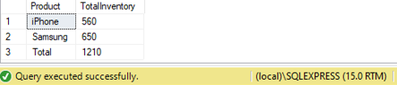

**Task No. 2:** Retrieve the order year, month, product name, and calculate the total sales by multiplying the quantity and unit price of each order detail (using Northwind)

perform the best suited technique such that the final result looks like this using Northwind.

**Solution:**

SELECT YEAR(o.OrderDate) as OrderYear, MONTH(o.OrderDate) as OrderMonth,

c.CategoryName, SUM(od.Quantity * od.UnitPrice) AS TotalSales

FROM Orders o

JOIN [Order Details] od ON o.OrderID = od.OrderID

JOIN Products p ON od.ProductID = p.ProductID

JOIN Categories c ON p.CategoryID = c.CategoryID

where YEAR(o.OrderDate) = 1997 and MONTH(o.OrderDate)= 1 and (c.CategoryName = 'Beverages'or c.CategoryName= 'Condiments')

GROUP BY ROLLUP(YEAR(o.OrderDate),MONTH(o.OrderDate), c.CategoryName)

ORDER BY OrderYear, OrderMonth, c.CategoryName desc;

**Output:**

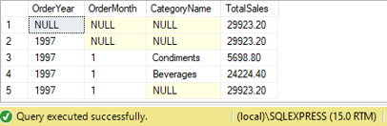

**Task No. 3:** Perform the best suited technique such that the final result looks like this using Northwind.

**Solution:**

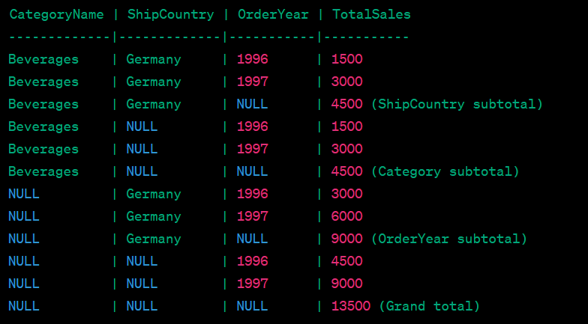SELECT c.CategoryName,o.ShipCountry as sCountry, YEAR(o.OrderDate) as OrderYear,

SUM(od.Quantity * od.UnitPrice) AS TotalSales

FROM Orders o

JOIN [Order Details] od ON o.OrderID = od.OrderID

JOIN Products p ON od.ProductID = p.ProductID

JOIN Categories c ON p.CategoryID = c.CategoryID

where o.ShipCountry= 'Germany' and (c.CategoryName = 'Beverages')

GROUP BY Cube(YEAR(o.OrderDate),o.ShipCountry, c.CategoryName)

ORDER BY c.CategoryName desc

**Output:**

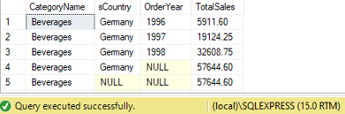

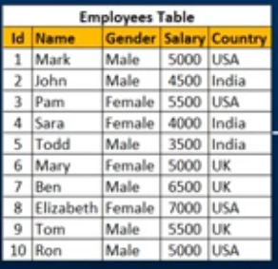**Task No. 4:** Create sample database then create the table given below and retrieve Salary by country along with grand total by rollup.

**Solution:**

Select r.Country ,SUM(r.Salary)as TotalSalary from RollUp as r

group by Rollup (r.Country)

**Output:**

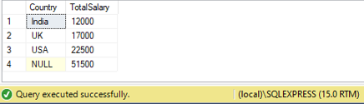

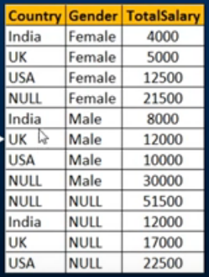**Task No. 5:** Write a query to retrieve Sum of Salary grouped by all combinations of the following:

2 columns as well as Grand Total. Country, Gender by using cube.

**Solution:**

SELECT COALESCE(Country, 'Total') AS Country, COALESCE(Gender, 'Total') AS Gender, SUM(TotalSalary) AS TotalSalary

FROM EmployeeDetails

GROUP BY ROLLUP (Country, Gender);

**Output:**

